**MEMO**

**TO:** Kelvin Sung

**FROM:** Jonathan Earl

Jason Herold

**DATE:** August 8th, 2016

**SUBJECT:** Capstone Progress Report: Week 7 Illumination

|  |
| --- |
| **PROGRESS** |

## Lighting

This week we added illuminate renderable/ light renderable support to the GUI.

Work Completed

1. User can generate Lights through the Light Tab
2. User can generate Materials through the Material Tab
3. User can load in a normal map texture in the Textures tab
4. User can change a TextureRenderable into a LightRenderable by checking the “Apply lighting” checkbox in Gameobject details
5. User can change a LightRenderable into a IllumRenderable by selecting a normal map texture from the dropdown in Gameobject details
6. User can change the material of a Gameobject
7. User can change Light/Material details through the UI
8. Light details change based on light type
9. User can change light details (x/y, near/far, Inner/outer). Directional lights don’t have a position in the scene, so they can’t have direct manipulation.
10. Save/load for lights, materials, light interaction objects, normal map textures
11. Light/Material deletion
12. Ambient light adjustment added to scene details

|  |
| --- |
| **Examples: Lighting** |

## Details

Light details change based on type Point / Directional / Spotlight

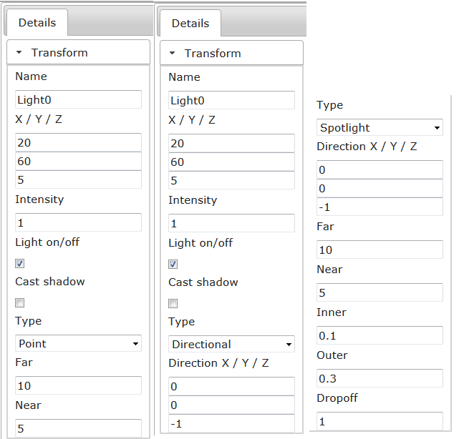

## Direct Light Controls

Direct point light interaction (Blue controls the near radius, red controls the far)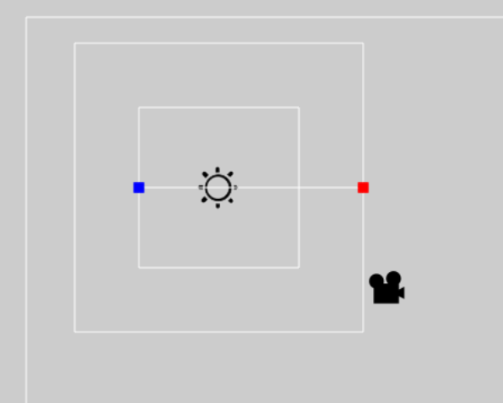

## Creating illumination gameObject

Adding normal map texture and enabling lighting + illumination on a GameObject

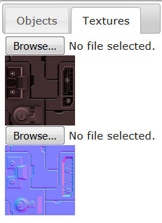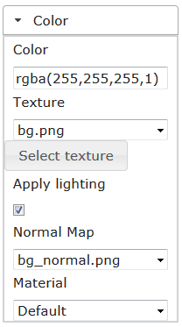

Lighting in editor

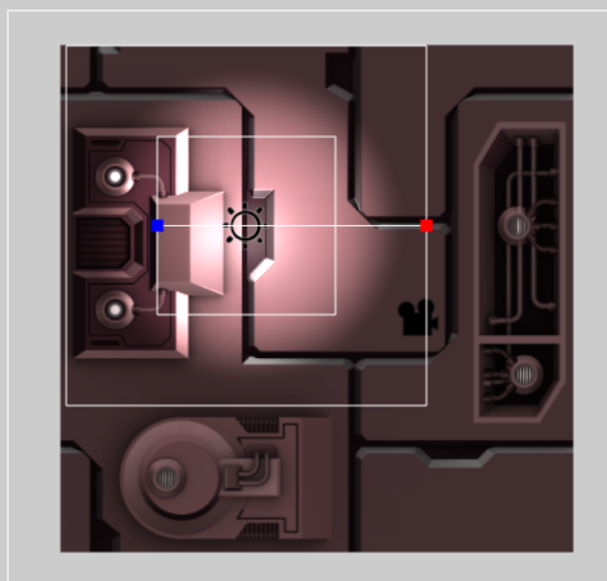

## Materials and Ambient Lighting

Get the details by selecting the material / scene in the materials and scene tab

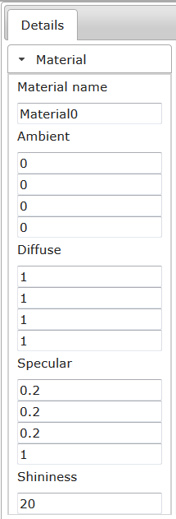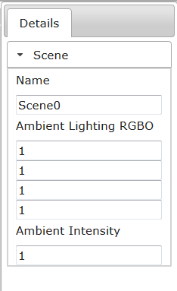

## Overview

Overall view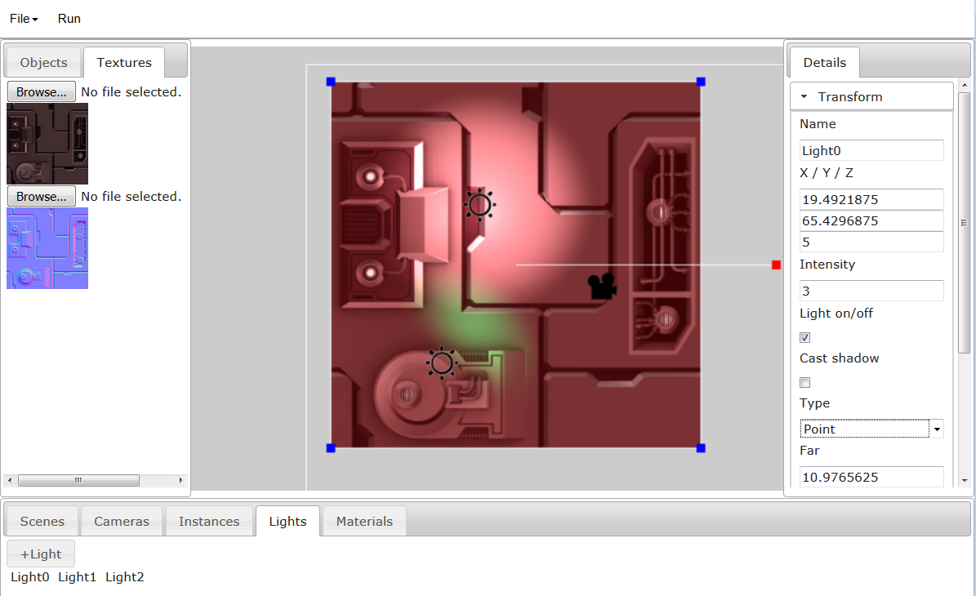

Game running

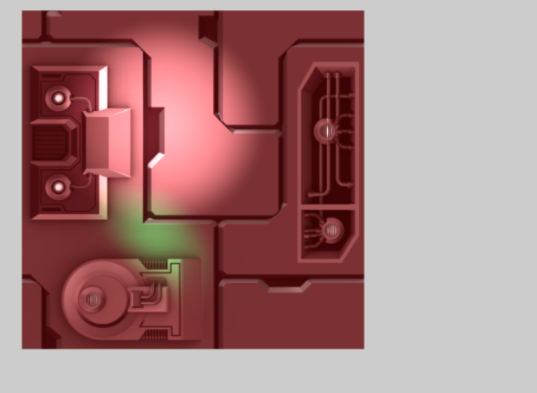

|  |
| --- |
| **Code Modifications** |

## Backend Modifications

**GuiBase_LightSupport.js:** Provides functions for adding and removing lights

**GuiBase_MaterialSupport.js:** Provides functions for adding and removing materials

**ClientScene.js:** Changed to store lights & light manipulation objects.

**GuiBase_SaveLoadSupport.js:** Saving and loading for normal map textures, lights, and materials

## Frontend Modifications

**LightContent.js**: Created to give the user access to the lights and add/delete lights

**LightTransformContent.js** Added to the details panel when the user selects a Light. Shows varying details depending on what type of light it is. Lets user change light details.

**LightObject.js**: Direct manipulation object for lights.

**MaterialContent.js**: Gives the user access to materials, adding/deleting materials

**MaterialInfoContent.js**: Material details

**ColorTextureContent.js**: Modified to allow GameObjects/instances to enable lighting on them and add illumination

**SceneInfo.js**: Ambient lighting support

**Checkbox.js**: Checkbox widget

|  |
| --- |
| **NEXT STEPS** |

## Poster and Presentation

For the poster/presentation we would like to split up the presentation by presenting our learnings on the front end changes and backend changes. Jason would like to do the front, and Jonathan the back. This would allow us to present more of our capstone with less overlap.

* Work on poster/presentation
* Code cleanup